**Practical-7**

**AIM: Understanding of Network Name Space**

**---------------------------------------------------------------------------------------------------------------------------**

Tools required:

1. Desktop Computer
2. Ubuntu Operating System

**Note:**

**1.** While applying IP address, student need to allocate IP address as per his/her student ID. For Example, if student ID is 20ce005 then IP address allocation for first network should start with 5.0.0.0. For subsequent network, it should start with ID+1 i.e. 6.0.0.0, 7.0.0.0. and so on.

**2.** Give your friend or family member name as interface

**Submission**: After writing answer into this word document, Student need to change name to his ID followed by practical number. Ex 20ce005_Pr1.docx. Upload on assignment segment.

**Rubrics**: Nicely drafted document with clarity in answers leads to full marks. Otherwise, submission carries proportional mark. Same day submission will be evaluated from 10 marks otherwise submission will be evaluated from 7 marks.

References

1. Iperf3: <https://iperf.fr/iperf-doc.php>

2. Wireshark Videos:

* Edit Windows
* Canvas Window
* Capturing Data
* Interpreting data in Wireshark
* Ethernet Frame
* IP Frame
* Throughput
* Flow diagram

Understanding Require

* IP Address
* URL
* Finding IP address from URL
* Finding location from IP Address

**Name Space**

**Install following packages**

sudo apt install iperf iperf3 netperf**﻿﻿** tcpdump wireshark

**Experiment-1:** Emulate point-to-point topology and note the values of parameters.

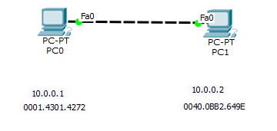

**Common Code**

sudo su

ip netns del red

ip netns del blue

ip netns add red

ip netns add blue

ip link add eth-red type veth peer name eth-blue

ip link set eth-red netns red

ip link set eth-blue netns blue

ip netns exec red ip link set lo up

ip netns exec red ip link set eth-red up

ip netns exec blue ip link set lo up

ip netns exec blue ip link set eth-blue up

ip netns exec red ip address add 28.0.0.1/24 dev eth-red

ip netns exec blue ip address add 28.0.0.2/24 dev eth-blue

#######Red##############

**Open New Terminal**

sudo su

ip netns exec red bash

iperf -s

#######Blue##############

**Open New Terminal**

sudo su

ip netns exec blue bash

iperf -c 28.0.0.1

**Start Server**

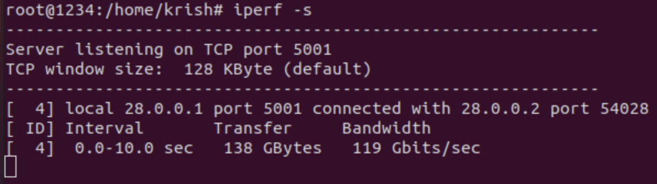

**Start Client**

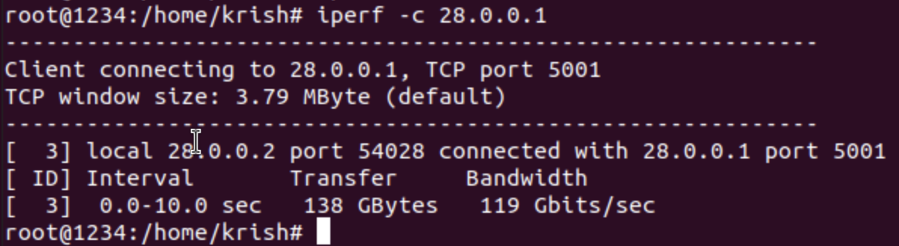

|  |  |
| --- | --- |
| **Particulars** | **Answer** |
| Server IP Address | 28.0.0.1 |
| Client IP address | 28.0.0.2 |
| Bandwidth between server and client | 119 Gbits/sec |
| Default port on which server listens data | 5001 |
| Default port on which client sends data | 54028 |

**Experiment-2**: Capturing packet inpoint-to-point topology and records the parameters.



**Execute the Common Code**

#######Red##############

**Open New Terminal**

sudo su

ip netns exec red bash

sudo wireshark &

##Start Capturing data

iperf -s

#######Blue##############

**Open New Terminal**

sudo su

ip netns exec blue bash

iperf -c 28.0.0.1 -n 1 -b 1

**Fill following table for any one packet**

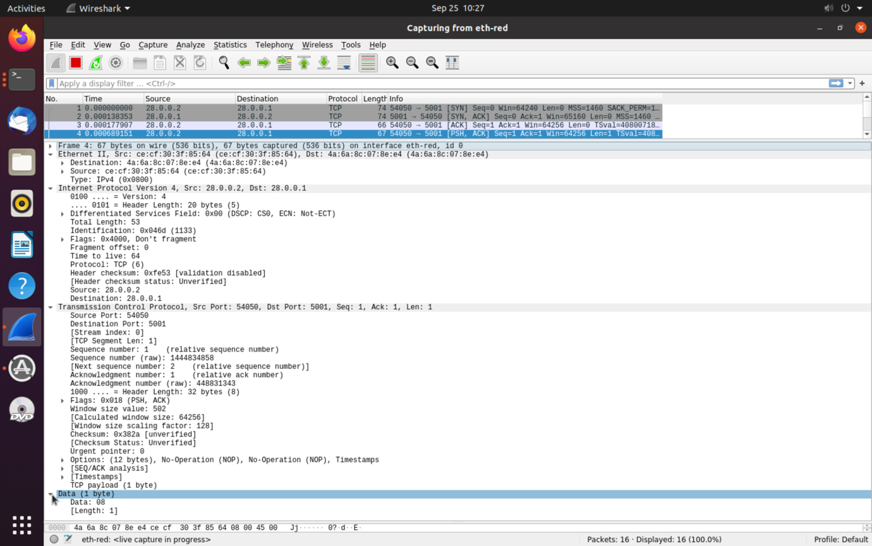

**Header fields of Ethernet**

|  |  |
| --- | --- |
| **Header field Name** | **Header field Value (Hex Value)** |
| Destination MAC Address | 4a:6a:bc:07:8e:e4 |
| Source MAC Address | ce:cf:30:3f:85:64 |
| Type | IPv4 |

**Header fields of Network**

|  |  |
| --- | --- |
| **Header field Name** | **Header field Value (Hex Value)** |
| Version | 4 |
| IHL | 20 Bytes |
| Source IP Address | 28.0.0.2 |
| Destination IP Address | 28.0.0.1 |

**Experiment-3**: Capturing packet inpoint-to-point topology and records the parameters.



**Execute the Common Code**

#######Red##############

**Open New Terminal**

sudo su

ip netns exec red bash

sudo wireshark &

##Start Capturing data

iperf -s -u

#######Blue##############

**Open New Terminal**

sudo su

ip netns exec blue bash

iperf -c 28.0.0.1 -n 1 -b 1 -u

**Fill following table for any one packet**

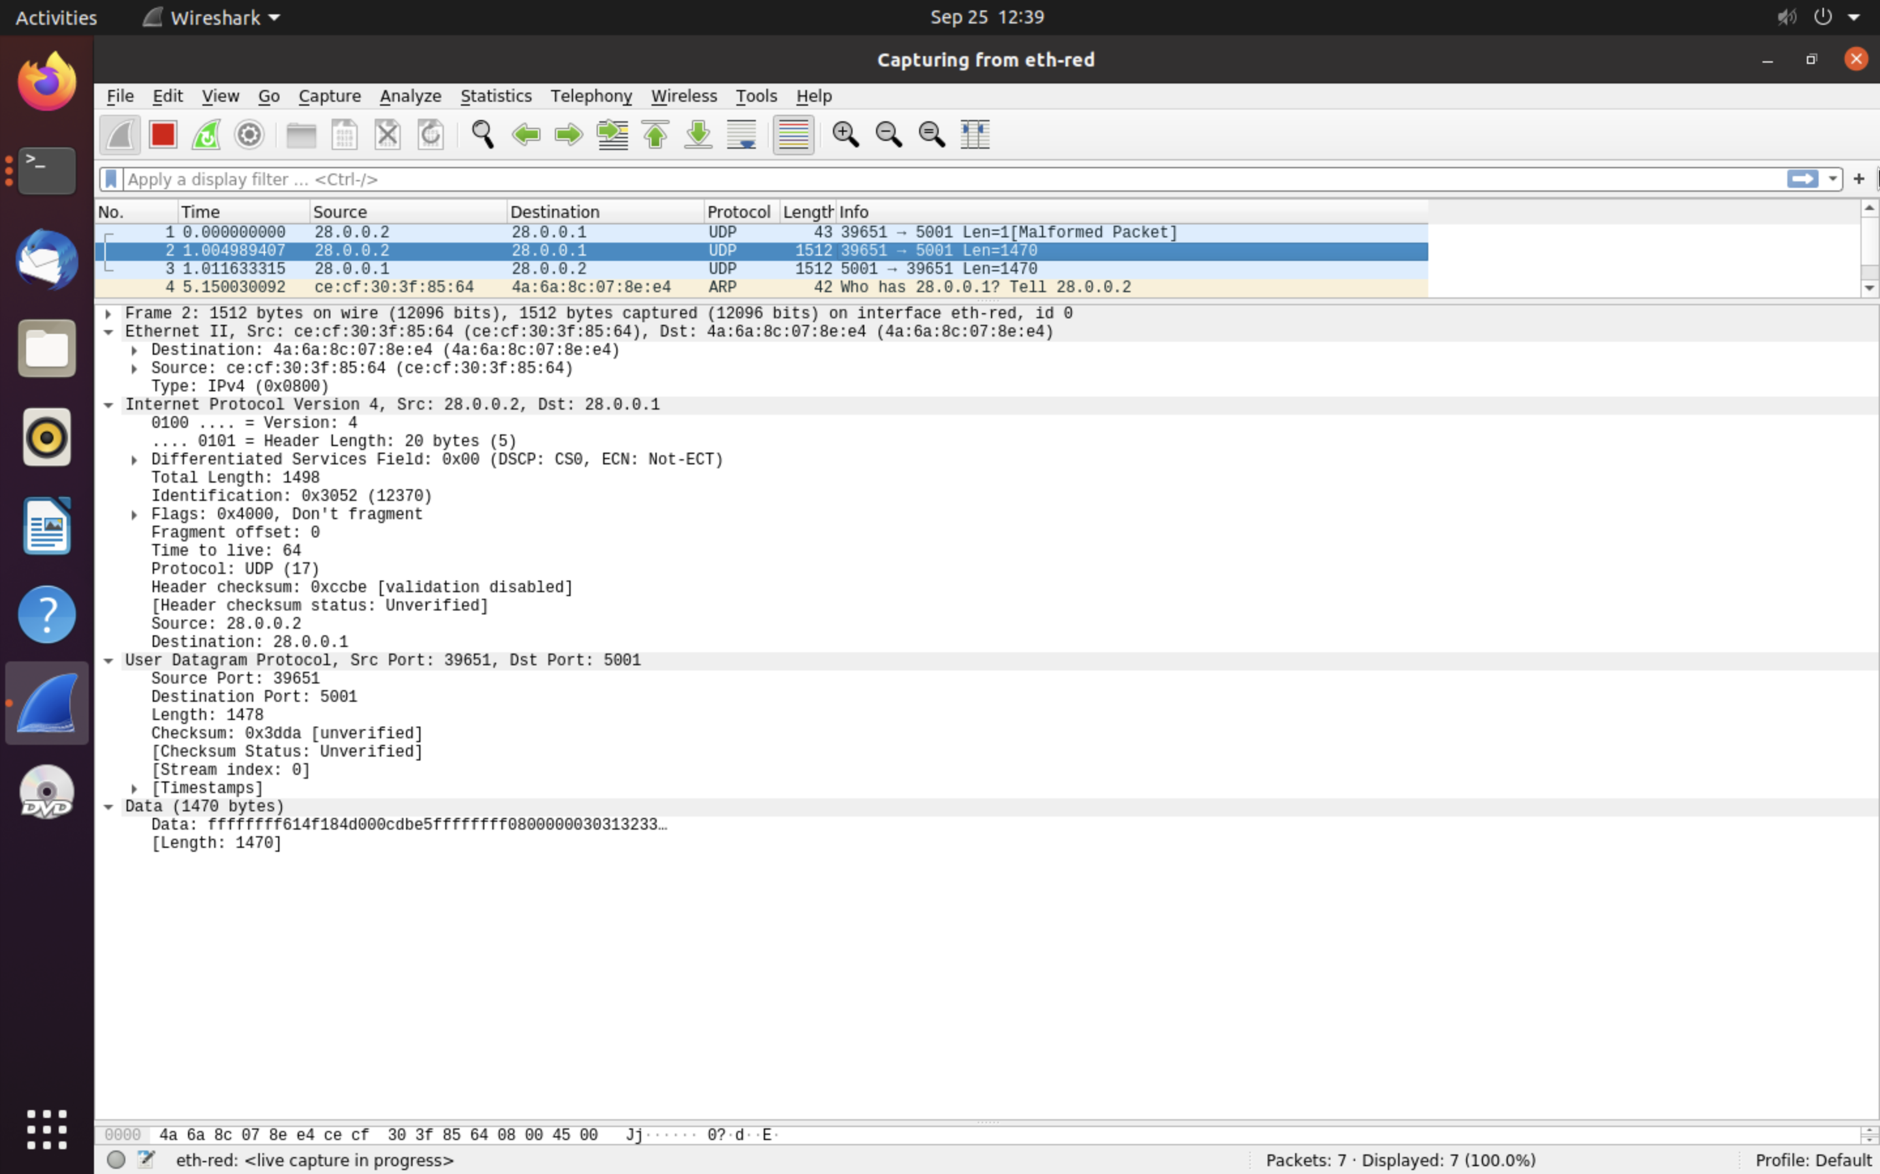

**Header fields of Network**

|  |  |
| --- | --- |
| **Header field Name** | **Header field Value (Hex Value)** |
| Version | 4 |
| IHL | 20 bytes |
| Total Length | 1498 |
| Checksum | 0x3dda |
| Source IP Address | 28.0.0.2 |
| Destination IP Address | 28.0.0.1 |

**Header fields of Transport Layer: TCP/UDP**

|  |  |
| --- | --- |
| **Header field Name** | **Header field Value (Hex Value)** |
| Source port | 39651 |
| Destination port | 5001 |
| Length | 1478 |
| Checksum | 0x3dda |

**Experiment-4:** Emulate point-to-point topology as per the parameters given in following topology.

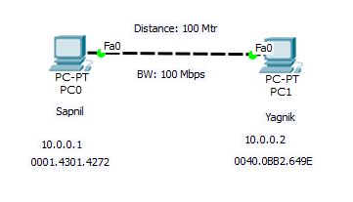

<<Student Topology with IP address and MAC address as label>>

Propagation Delay = Distance/3*10^8

#######Red##############

**Open New Terminal**

sudo su

ip netns exec red bash

tc qdisc show dev eth-red

tc qdisc add dev eth-red root netem delay 0.002ms rate 100mbit

iperf -s

#######Blue##############

**Open New Terminal**

sudo su

ip netns exec blue bash

tc qdisc show dev eth-blue

tc qdisc add dev eth-blue root netem delay 0.002ms rate 100mbit

iperf -c 28.0.0.1

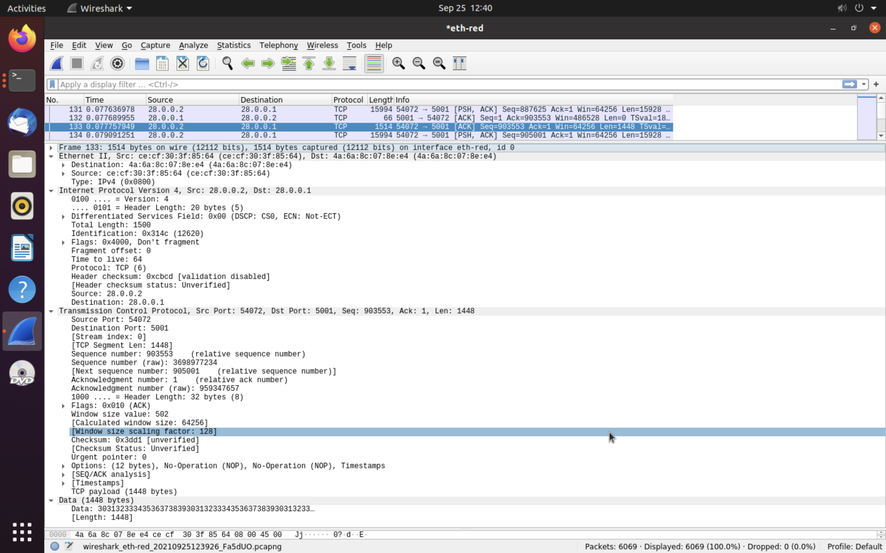

**Header fields of Network**

|  |  |
| --- | --- |
| **Header field Name** | **Header field Value (Hex Value)** |
| Version | 4 |
| IHL | 20 bytes |
| Total Length | 1500 |
| Checksum | 0xcbcd |
| Source IP Address | 28.0.0.2 |
| Destination IP Address | 28.0.0.1 |

**Header fields of Transport Layer: TCP/UDP**

|  |  |
| --- | --- |
| **Header field Name** | **Header field Value (Hex Value)** |
| Source port | 54072 |
| Destination port | 5001 |
| Length | 1448 |
| Checksum | 0x3dd1 |

**Experiment-5:** Emulate point-to-point topology as per the parameters given in following topology and write the code below topology.

A.

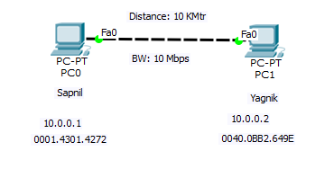

#######Red##############

**Open New Terminal**

sudo su

ip netns exec red bash

tc qdisc show dev eth-red

tc qdisc add dev eth-red root netem delay 0.2ms rate 10mbit

iperf -s

#######Blue##############

**Open New Terminal**

sudo su

ip netns exec blue bash

tc qdisc show dev eth-blue

tc qdisc add dev eth-blue root netem delay 0.2ms rate 10mbit

iperf -c 28.0.0.1

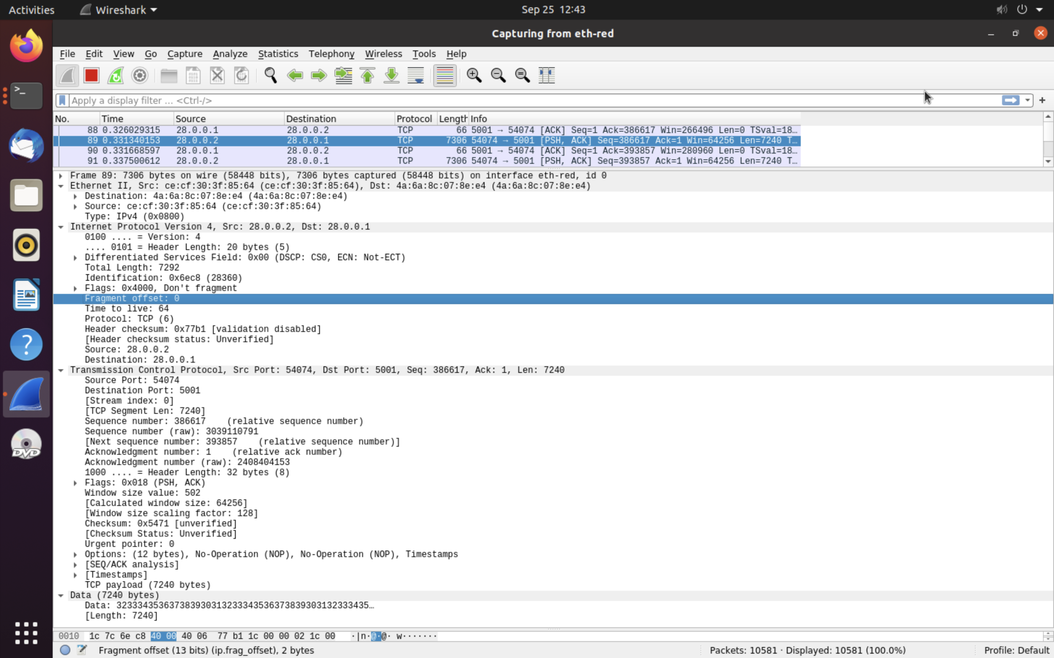

**Header fields of Network**

|  |  |
| --- | --- |
| **Header field Name** | **Header field Value (Hex Value)** |
| Version | 4 |
| IHL | 20 bytes |
| Total Length | 7292 |
| Checksum | 0x77b1 |
| Source IP Address | 28.0.0.2 |
| Destination IP Address | 28.0.0.1 |

**Header fields of Transport Layer: TCP/UDP**

|  |  |
| --- | --- |
| **Header field Name** | **Header field Value (Hex Value)** |
| Source port | 54074 |
| Destination port | 5001 |
| Length | 7240 |
| Checksum | 0x5471 |

B.

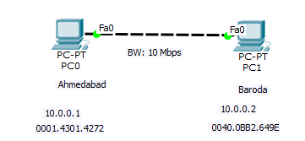

#######Red##############

**Open New Terminal**

sudo su

ip netns exec red bash

tc qdisc show dev eth-red

tc qdisc add dev eth-red root netem delay 0.32ms rate 10mbit

iperf -s

#######Blue##############

**Open New Terminal**

sudo su

ip netns exec blue bash

tc qdisc show dev eth-blue

tc qdisc add dev eth-blue root netem delay 0.32ms rate 10mbit

iperf -c 28.0.0.1

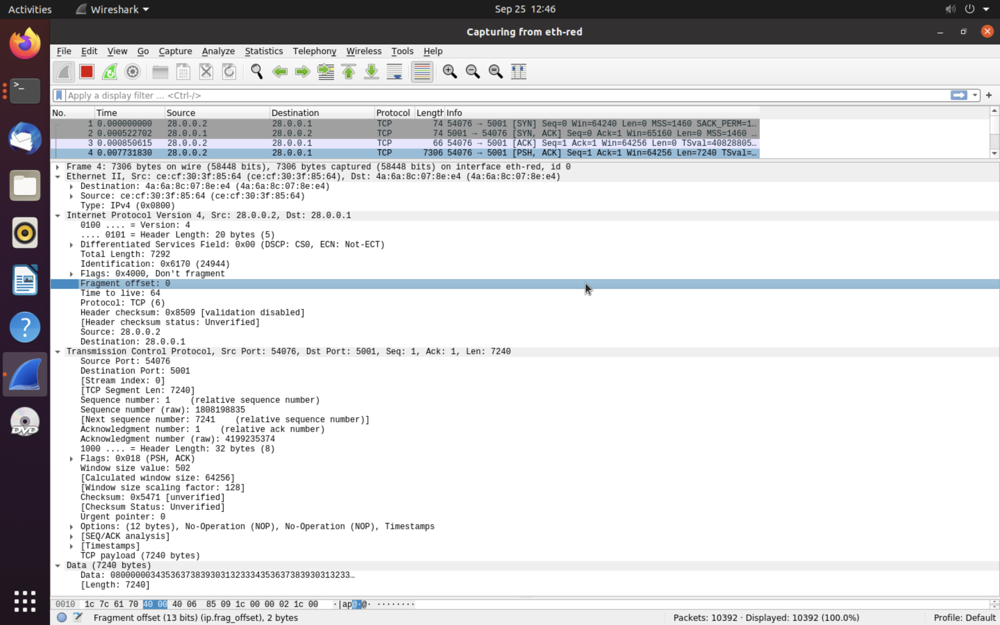

**Header fields of Network**

|  |  |
| --- | --- |
| **Header field Name** | **Header field Value (Hex Value)** |
| Version | 4 |
| IHL | 20 bytes |
| Total Length | 7292 |
| Checksum | 0x6179 |
| Source IP Address | 28.0.0.2 |
| Destination IP Address | 28.0.0.1 |

**Header fields of Transport Layer: TCP/UDP**

|  |  |
| --- | --- |
| **Header field Name** | **Header field Value (Hex Value)** |
| Source port | 54076 |
| Destination port | 5001 |
| Length | 7240 |
| Checksum | 0x5471 |

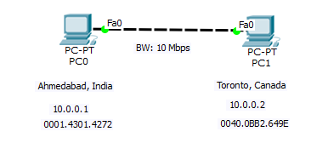C.

#######Red##############

**Open New Terminal**

sudo su

ip netns exec red bash

tc qdisc show dev eth-red

tc qdisc add dev eth-red root netem delay 40.2ms rate 10mbit

iperf -s

#######Blue##############

**Open New Terminal**

sudo su

ip netns exec blue bash

tc qdisc show dev eth-blue

tc qdisc add dev eth-blue root netem delay 40.2ms rate 10mbit

iperf -c 28.0.0.1

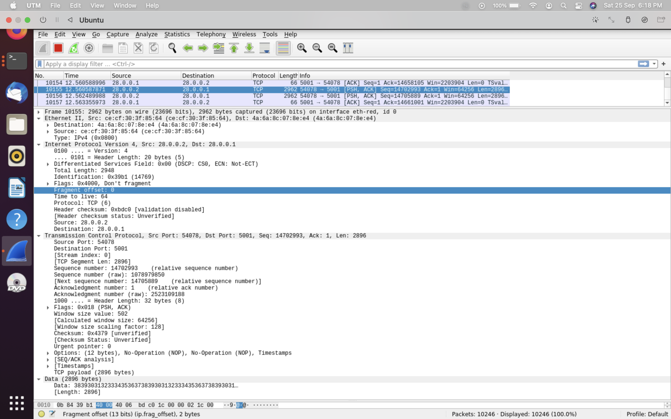

**Header fields of Network**

|  |  |
| --- | --- |
| **Header field Name** | **Header field Value (Hex Value)** |
| Version | 4 |
| IHL | 20 bytes |
| Total Length | 2948 |
| Checksum | 0x39b1 |
| Source IP Address | 28.0.0.2 |
| Destination IP Address | 28.0.0.1 |

**Header fields of Transport Layer: TCP/UDP**

|  |  |
| --- | --- |
| **Header field Name** | **Header field Value (Hex Value)** |
| Source port | 54078 |
| Destination port | 5001 |
| Length | 2896 |
| Checksum | 0x4379 |

**Experiment-6:** Emulate point-to-point topology as per the parameters given in following topology and write the code below topology.

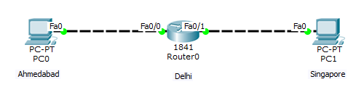

**sudo su**

**ip netns del ahmedabad**

**ip netns del singapore**

**ip netns del router**

**ip netns add ahmedabad**

**ip netns add singapore**

**ip netns add router**

**ip link add eth-ahmedabad type veth peer name eth-router0**

**ip link add eth-router1 type veth peer name eth-singapore**

**ip link set eth-ahmedabad netns ahmedabad**

**ip link set eth-singapore netns singapore**

**ip link set eth-router0 netns router**

**ip link set eth-router1 netns router**

**ip netns exec ahmedabad ip link set lo up**

**ip netns exec singapore ip link set lo up**

**ip netns exec router ip link set lo up**

**ip netns exec ahmedabad ip link set eth-ahmedabad up**

**ip netns exec router ip link set eth-router0 up**

**ip netns exec router ip link set eth-router1 up**

**ip netns exec singapore ip link set eth-singapore up**

**ip netns exec ahmedabad ip address add 28.0.0.1/24 dev eth-ahmedabad**

**ip netns exec router ip address add 28.0.0.2/24 dev eth-router0**

**ip netns exec router ip address add 29.0.0.1/24 dev eth-router1**

**ip netns exec singapore ip address add 29.0.0.2/24 dev eth-singapore**

**ip netns exec ahmedabad ip route add default via 28.0.0.2 dev eth-ahmedabad**

**ip netns exec singapore ip route add default via 29.0.0.1 dev eth-singapore**

**ip netns exec router sysctl -w net.ipv4.ip_forward=1**

**#######Router ##############**

**Open New Terminal**

**sudo su**

**ip netns exec router bash**

**tc qdisc add dev eth-router0 root netem delay 4ms rate 10mbit**

**tc qdisc add dev eth-router1 root netem delay 20ms rate 10mbit**

**#######ahmedabad ##############**

**Open New Terminal**

**sudo su**

**ip netns exec ahmedabad bash**

**ping 29.0.0.2**

**tc qdisc show dev eth-ahmedabad**

**iperf -s**

**#######singapore ##############**

**Open New Terminal**

**sudo su**

**ip netns execred bash**

**ping 28.0.0.1**

**tc qdisc show dev eth-singapore**

**iperf -c 28.0.0.1**

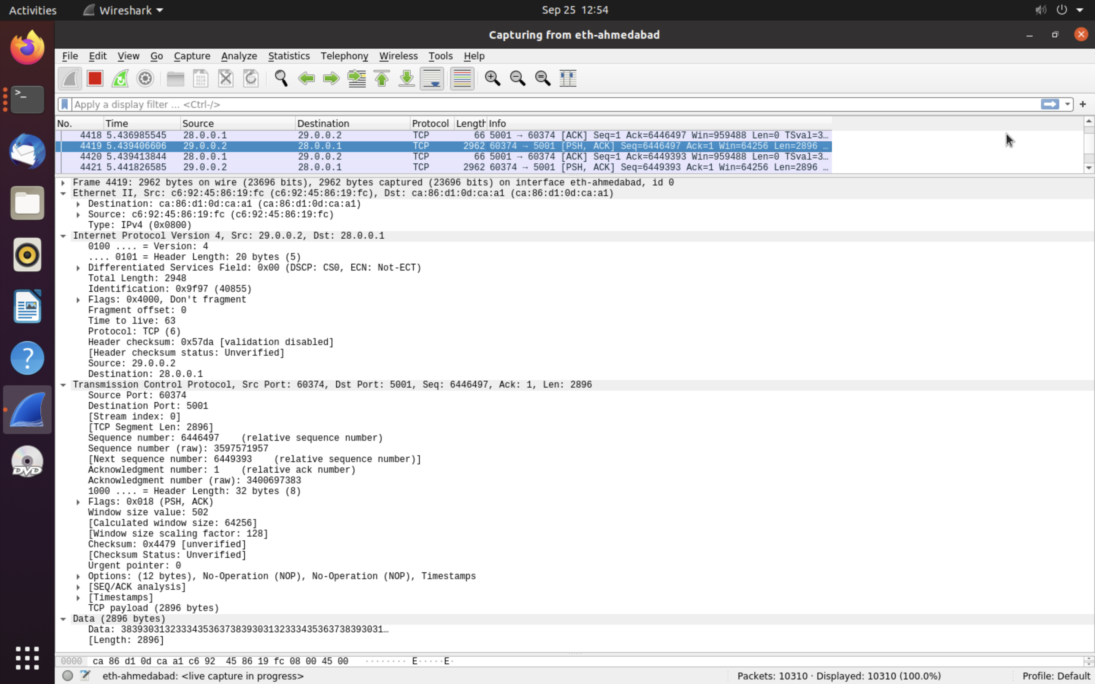

**Header fields of Network**

|  |  |
| --- | --- |
| **Header field Name** | **Header field Value (Hex Value)** |
| Version | 4 |
| IHL | 20 bytes |
| Total Length | 2948 |
| Checksum | 0x9f97 |
| Source IP Address | 28.0.0.1 |
| Destination IP Address | 28.0.0.2 |

**Header fields of Transport Layer: TCP/UDP**

|  |  |
| --- | --- |
| **Header field Name** | **Header field Value (Hex Value)** |
| Source port | 60374 |
| Destination port | 5001 |
| Length | 2896 |
| Checksum | 0x4479 |

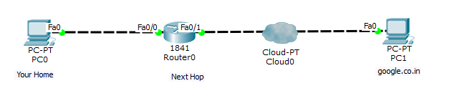**sudo su**

**ip netns del home**

**ip netns del google**

**ip netns del router**

**ip netns add home**

**ip netns add google**

**ip netns add router**

**ip link add eth-home type veth peer name eth-router0**

**ip link add eth-router1 type veth peer name eth-google**

**ip link set eth-home netns home**

**ip link set eth-google netns google**

**ip link set eth-router0 netns router**

**ip link set eth-router1 netns router**

**ip netns exec home ip link set lo up**

**ip netns exec google ip link set lo up**

**ip netns exec router ip link set lo up**

**ip netns exec home ip link set eth-home up**

**ip netns exec router ip link set eth-router0 up**

**ip netns exec router ip link set eth-router1 up**

**ip netns exec google ip link set eth-google up**

**ip netns exec home ip address add 28.0.0.1/24 dev eth-home**

**ip netns exec router ip address add 28.0.0.2/24 dev eth-router0**

**ip netns exec router ip address add 29.0.0.1/24 dev eth-router1**

**ip netns exec google ip address add 29.0.0.2/24 dev eth-google**

**ip netns exec home ip route add default via 28.0.0.2 dev eth-home**

**ip netns exec google ip route add default via 29.0.0.1 dev eth-google**

**ip netns exec router sysctl -w net.ipv4.ip_forward=1**

**#######Router ##############**

**Open New Terminal**

**sudo su**

**ip netns exec router bash**

**tc qdisc add dev eth-router0 root netem delay 3.1ms rate 10mbit**

**tc qdisc add dev eth-router1 root netem delay 34ms rate 10mbit**

**####### home ##############**

**Open New Terminal**

**sudo su**

**ip netns exec home bash**

**ping 29.0.0.2**

**tc qdisc show dev eth-home**

**iperf -c 29.0.0.2**

**####### google ##############**

**Open New Terminal**

**sudo su**

**ip netns exec google bash**

**ping 28.0.0.1**

**tc qdisc show dev eth-google**

**iperf -s**

###########Delay##########

Propagation Delay = Distance/3*10^8

Distance from Home to Next Hop: 931 km (Delhi)

Propagation Delay =3.1ms

Distance from next hop to google.co.in: 10207km (Brisbane, Queensland)

Propagation Delay =34ms

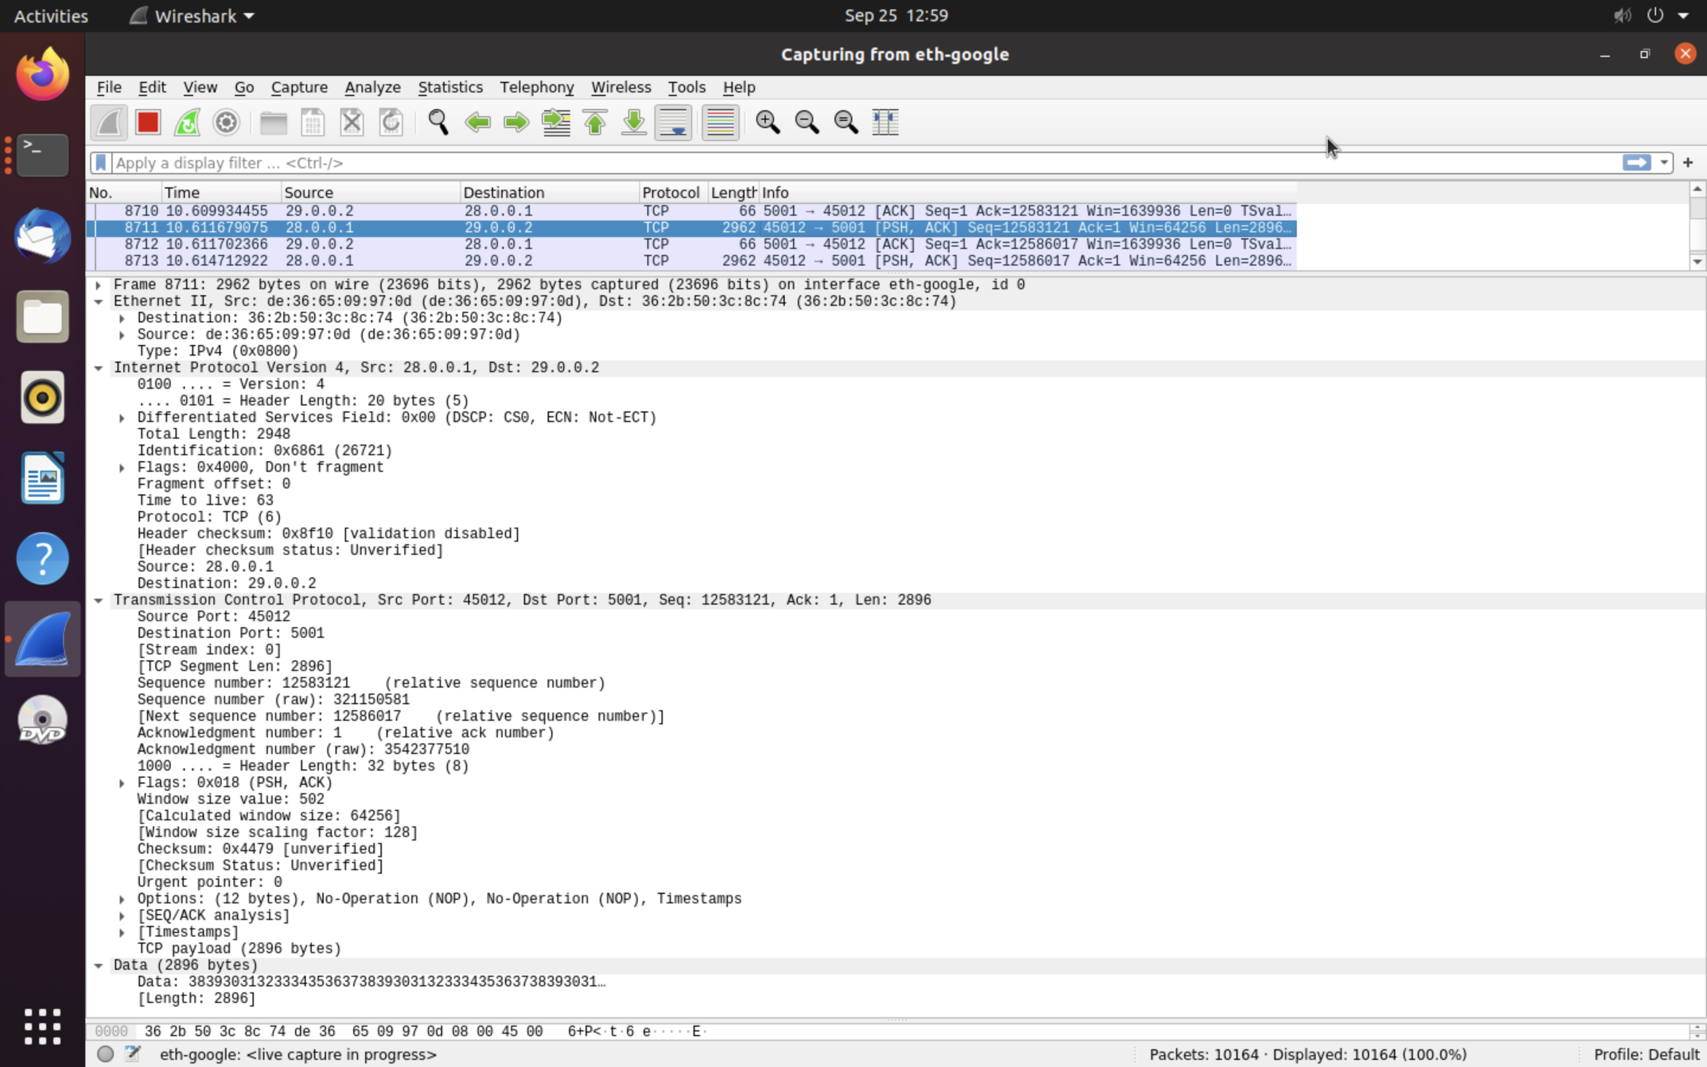

**Header fields of Network**

|  |  |
| --- | --- |
| **Header field Name** | **Header field Value (Hex Value)** |
| Version | 4 |
| IHL | 20 bytes |
| Total Length | 2948 |
| Checksum | 0x8f10 |
| Source IP Address | 28.0.0.1 |
| Destination IP Address | 29.0.0.2 |

**Header fields of Transport Layer: TCP/UDP**

|  |  |
| --- | --- |
| **Header field Name** | **Header field Value (Hex Value)** |
| Source port | 45012 |
| Destination port | 5001 |
| Length | 2896 |
| Checksum | 0x4479 |

**Questions:**

1. **What do you mean by server and client?**

**Answer:**

* Server - A system that provides services to other systems in its network. There are file servers, boot servers, database servers, license servers, print servers, installation servers, and even servers for particular applications. This chapter uses the term server to mean a system that provides file systems and installation software for other systems on the network.
* Client - A system that uses remote services from a server. Some clients have limited disk storage capacity, or perhaps none at all, and they have to rely on remote file systems from a server to function.

Other clients might use remote services (such as installation software) from a server, but they don't rely on a server to function. A standalone system, which has its own hard disk containing the root (/), /usr, and /export/home file systems and swap space, is a good example of this type of client.

2**. When your computer becomes Server?**

**Answer:**

When different computer which are connected on network and requesting our computer to given services which become in listening mode then our computer becomes server.

**3. When your computer becomes Client?**

**Answer:**

When our computer want services from another computer which is in sending mode then our computer becomes client.